Multipliers Determiners

🔹 What Are Multipliers Determiners?
# Source: AI Source: Provided by: [Data Path: Persons Table -> ID Column: 1, Name_En Column: Motasem Essam] -> From: [Chatgpt (GPT-4-turbo)] on [7/28/2025]
Multipliers Determiners are number-based determiners that express multiplication, repetition, or increased degree of something.
They answer the question “How many times?” or “How much more?”

✅ Common Multipliers:
# Source: AI Source: Provided by: [Data Path: Persons Table -> ID Column: 1, Name_En Column: Motasem Essam] -> From: [Chatgpt (GPT-4-turbo)] on [7/28/2025]
- double
- triple
- twice
- thrice
- quadruple (less common)

✅ Function:
# Source: AI Source: Provided by: [Data Path: Persons Table -> ID Column: 1, Name_En Column: Motasem Essam] -> From: [Chatgpt (GPT-4-turbo)] on [7/28/2025]
They come before a noun to modify it — just like other determiners — and tell how many times more of something is referred to.

✅ Examples in Sentences:
# Source: AI Source: Provided by: [Data Path: Persons Table -> ID Column: 1, Name_En Column: Motasem Essam] -> From: [Chatgpt (GPT-4-turbo)] on [7/28/2025]
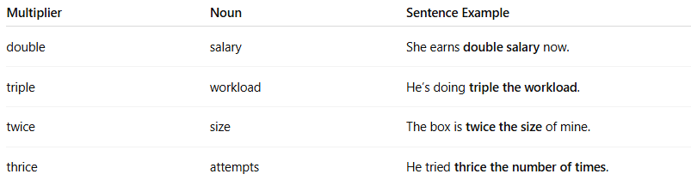
Multiplier | Noun | Sentence Example
double | salary | She earns double salary now.
triple | workload | He’s doing triple the workload.
twice | size | The box is twice the size of mine.
thrice | attempts | He tried thrice the number of times.
Note: Sometimes "twice", "thrice", etc., are used more adverbially, but when they directly modify nouns, they act as determiners.

🔁 Difference from Cardinal Numbers:
# Source: AI Source: Provided by: [Data Path: Persons Table -> ID Column: 1, Name_En Column: Motasem Essam] -> From: [Chatgpt (GPT-4-turbo)] on [7/28/2025]
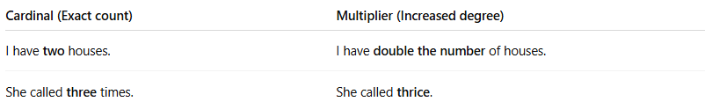
Cardinal (Exact count) | Multiplier (Increased degree)
I have two houses. | I have double the number of houses.
She called three times. | She called thrice.

